Lab3

a.

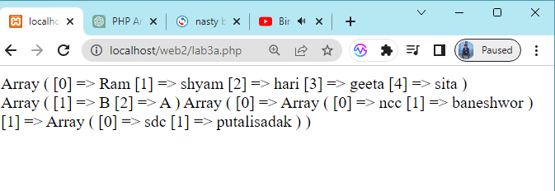

3b1

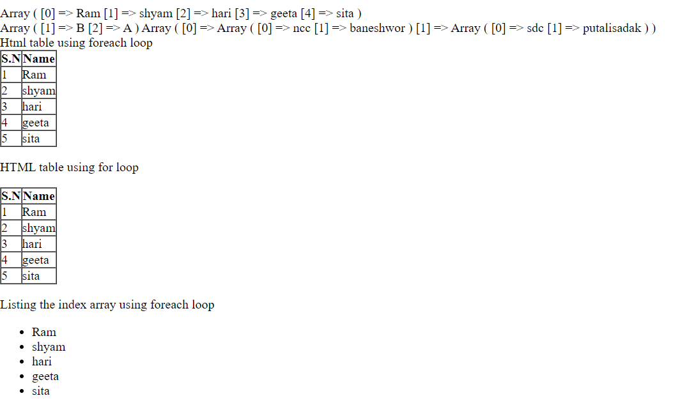

3b2

3b3

3c

3e

3f

Lab4

D

E

F

G

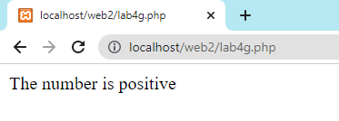

**Lab5**

**Form validation**

A

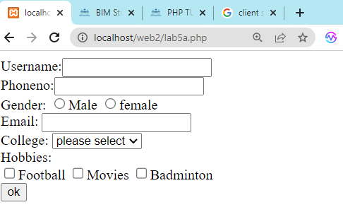

Validation

